# Artificial Vision System for Meat Quality Gradation



## B. Tech. Project Report

By

### Name of the B. Tech. Students

**Shubhodeep Chanda Arunima Chaudhuri Debdoot Roy Chowdhury Bidesh Banerjee**

**Under Supervision of Kingshuk Chatterjee**

**Department of Computer Sc. and Engineering**

**Government College of Engineering and Ceramic Technology**

## Kolkata

**November 2022**

# Artificial Vision System for Meat Quality Gradation



### A Project Report

*Submitted in partial fulfillment of the requirements for the award of the degree* ***of***

### Bachelor of Technology In

**Computer Sc. and Engineering**

*By*

**Shubhodeep Chanda (GCECTB-R19-3026) Arunima Chaudhuri (GCECTB-R19-3008) Debdoot Roy Chowdhury (GCECTB-R19-3014) Bidesh Banerjee (GCECTB-R19-3013)**

**Department of Computer Sc. and Engineering**

**Government College of Engineering and Ceramic Technology**

## Kolkata

**November 2022**

#### Name and Roll No. of the Students Signature of the Students

1. Arunima Chaudhuri, GCECTB-R19-3008
2. Debdoot Roy Chowdhury, GCECTB-R19-3014
3. Bidesh Banerjee, GCECTB-R19-3013
4. Shubhodeep Chanda, GCECTB-R19-3026

**Place: Kolkata Date:**

**Government College of Engineering and Ceramic Technology**

**73, A. C. Banerjee Lane, Kolkata, West Bengal 700010**

**………………………………………………………………………… BONAFIDE CERTIFICATE**

Certified that this project report titled **Artificial Vision System for Meat Quality Gradation** is the realistic work carried out by **Arunima Chaudhuri(GCECTB- R19-3008), Debdoot Roy Chowdhury(GCECTB-R19-3014), Bidesh Banerjee(GCECTB- R19-3013), Shubhodeep Chanda(GCECTB-R19-3026)** who will carried out the project work under **my / our** supervision.

*…………………………………..*

#### Kingshuk Chatterjee SUPERVISOR

Assistant Professor

Department of Computer Science and Engineering Government College of Engineering and

Ceramic Technology Kolkata-700010

*………………………………….. …………………………………………*

#### Dr. K. Saha Roy External Examiner

**HEAD OF THE DEPARTMENT**

Assistant Professor & Head

Department of Computer Science and Engineering Government College of Engineering and

Ceramic Technology Kolkata-700010

### Abstract

**In this study of the meat freshness determination a system is developed which uses digital image processing to determine the freshness quality the three most consumed meat in the India namely: (1) Chicken, (2) Fish (Ompok Bimaculatus) and (3) Prawn Fish (Decapterus maruadsi).**

**Moreover, we used multiple classification methods based on Machine Learning algorithms that would classify the meat according to their quality as consumable or non-consumable. Image acquisition’s results in the form of 8 bits’ digital data at each base color RGB (Red, Green, Blue) is converted into HSV (Hue, Saturation, Value) color space to see the difference of its brightness, hue, saturation and other important color aspects. The steps of classification of meat according to their quality went through image acquisition by using a digital camera, pre-processing the image, and extracting its feature by color analysis & feeding it into multiple models.**

Introduction

A computer vision technique of gradation includes first image processing and then applying classification model for analysis. This is achieved by using machine learning algorithms, which is a nondestructive and non-hazardous method of assessment, based on photography and analysis of its color variations and evaluating its freshness with the help of a machine learning model.

We have used four machine learning models here to evaluate the freshness of chicken, fish and prawn image datasets. The four machine learning models are statistical models such as Naive Bayes, KNN, SVM and Random Forest. Here we have the datasets in RGB color space.

We have converted the images to HSV. The HSV model is a color system that detects the workings of the human eye. HSV combines information, both color and grayscale from an image. HSV comes from the Hue, Saturation, Value. Where Hue describes pure colors like red, blue, or yellow. Saturation describes the degree to which pure colors are softened in white. The range of values is between dark (black) and bright (white). Hue is the attribute that states the number of true colors such as red, yellow, and violet used to distinguish colors and determine the level of redness (greenness). Hue is associated with the wavelength of light. So, if the hue states the actual color, then saturation states the color size get the value of the HSV color model value the conversion of the RGB to HSV [1] color model involves parameters as input data such as red, green and blue signals for each pixel and three other parameters such as hue, saturation and value as output.

R, G, B in RGB are all correlated to the color luminance (what we loosely call intensity), i.e., We cannot separate color information from luminance. HSV or Hue Saturation Value is used to separate image luminance from color information. This makes it easier when we are working on or need luminance of the image/frame. HSV is also used in situations where color description plays an integral role.

The use of HSV rather than RGB space is beneficial in texture analysis. Paschos demonstrates that perceptually uniform spaces, such as HSV and L*a*b*, outperform nonuniform RGB. He concludes, according to experimental results, that HSV could be a superior color space, compared to RGB, for color texture analysis. In noisy conditions the HSV performs better than the L*a*b*.

Most models predicted on average greater than 80%. We have discussed each of the datasets and models with clear working principles of each of those models in the paper and then analyzed and showed which model and color space worked better for each of the dataset.

Dataset

1. **Fish** - The live Fish (Pabda) were sampled live from a local aquatic products market in Kolkata of India and kept in three hundred liters aquariums for 24 h. The average weight and average length of fishes were 90.40 ± 1.20 g and 21.60 ± 0.50 cm respectively. The pond water from which it was collected was free from any pathogenic infestation and toxic residues.  
   Fishes from the aquariums were taken out and placed into chilled water for sudden death to avoid rigor mortis. The fishes thereafter were preserved for imaging study in thermocol boxes (28 x 18 x 12 cm3) with a fish to ice ratio of 1:2. Images of fish were taken using a digital camera and the distance between the fish and the camera was as far as 10 cm. The captured images are of the size 601 x 361 pixels.

The fish images were captured starting from day one of death and at every two days' interval till the 10th day. Fish was stored in a freezer in the intermediate days with a temperature of 0 degree Celsius. Fish images classified as consumable (Refer Fig 1.1.1) were taken till 4-5 days from day one of death, and fish classified as non-consumable (Refer Fig 1.1.2) were taken from 5-6 days of death till the 10th day. The process of taking the image of fish meat is carried out in an open area which is illuminated by the natural sunlight. After the process of taking the image data, a certain part of the image object would be cropped[4].

The proposed image processing based method of freshness identification in fish samples involves feature extraction from the color difference in stomach area. To extract the accurate and discriminatory features from the image, the portion of the image which contains maximum information is required to be segmented from the whole image. After the process of taking the image data, the RGB image (Refer Fig 1.1.1 and 1.1.2) is then converted into HSV [1] (Refer Fig 1.1.3 and 1.1.4) for further processing.

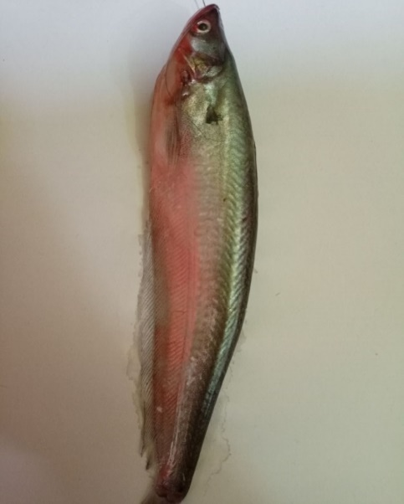 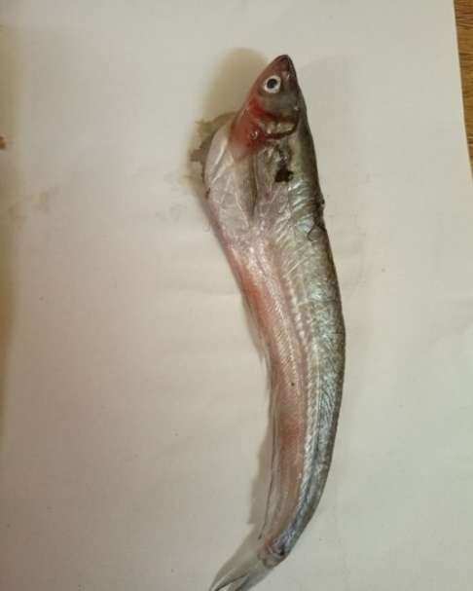

Fig. 1.1.1 Consumable (RGB)        Fig. 1.1.2 Non-consumable (RGB)

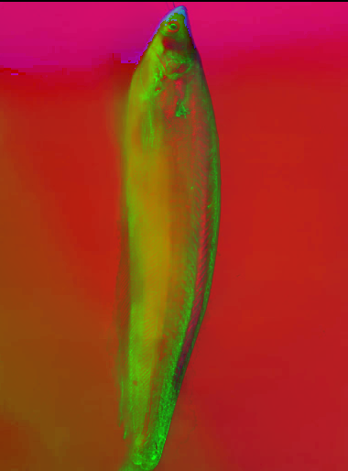 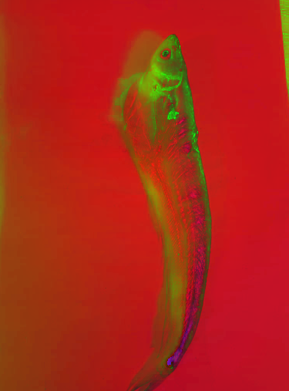

Fig. 1.1.3 Consumable (HSV)      Fig. 1.1.4 Non-Consumable (HSV)

1. **Chicken** - The chicken meat was sampled from a local market where the chicken was brought alive from a nearby poultry. Breast meat portion was used as a sample for the dataset. The chicken breast is cut to various lengths and widths but with almost uniform thickness, approximately 0.5 cm. The process of capturing chicken meat image data used a digital camera and the distance between the chicken meat and the camera was as far as 10 cm. The captured images are of the size 601 x 361 pixels.

The chicken meat images were captured starting from day one of slaughter and at every two days' interval till 13th day. Meat was stored in a freezer in the intermediate days with a temperature of 0 degree Celsius. Meat images classified as consumable (Refer Fig 1.2.1) were taken till 5-6 days from day one of death, and meat classified as non-consumable (Refer Fig 1.2.2) were taken from 5-6 days of death till the 13th day. The process of taking the image of chicken meat is carried out in an open area which is illuminated by the natural sunlight. After the process of taking the image data, a certain part of the image object would be cropped.

The proposed image processing based method of freshness identification in chicken meat samples involves feature extraction from the color difference. [3] To extract the accurate and discriminatory features from the image, the portion of the image which contains maximum information is required to be segmented from the whole image. After the process of taking the image data, the RGB image (Refer Fig 1.2.1 and 1.2.2) is then converted into HSV [1] (Refer Fig 1.2.3 and 1.2.4) for further processing.

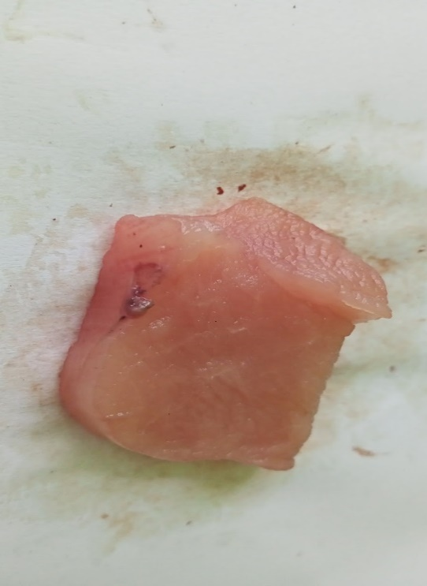 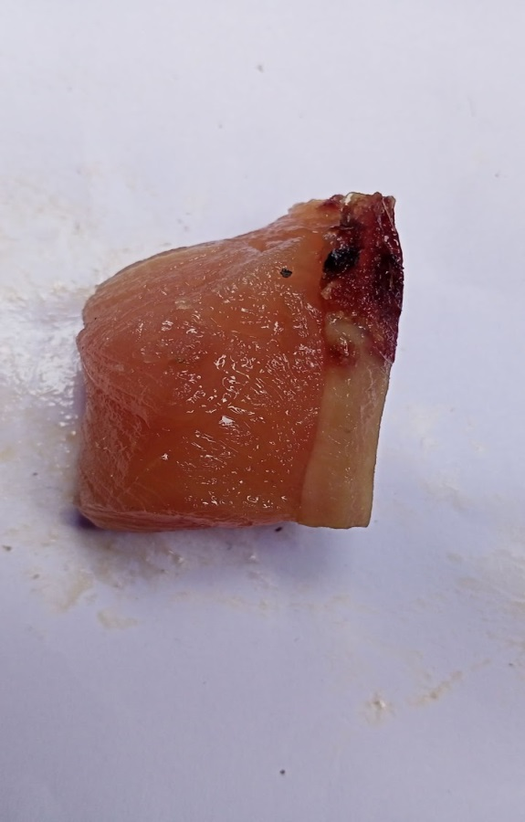

Fig. 1.2.1 Consumable (RGB)     Fig. 1.2.2 Non-Consumable (RGB)

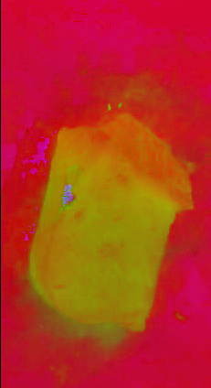 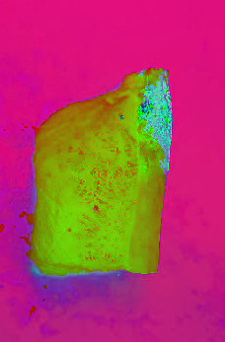

                 Fig. 1.2.3 Consumable (HSV)   Fig. 1.2.4 Non-Consumable (HSV)

1. **Prawn** - Fresh white-leg prawn each of approximately 24 ± 2 g in weight and 17 ± 2 cm in length were sampled from a local aquatic products market Kolkata of India. The shrimp were kept in seawater with ice and were transferred to the laboratory within 2 hours of purchase. After prawn with signs of visual defect or breakage were removed, the remaining shrimp were picked out. The shrimp were washed clean with tap water. The meat sample was collected immediately by hand with gloves to prevent contamination.

The prawn images were captured starting from day one of purchase and at every one day interval till 7th day. It was stored in a freezer in the intermediate days with a temperature of 0 degree Celsius. Images classified as consumable (Refer Fig 1.3.1) were taken till 3-4 days from the day one of death, and images classified as non-consumable (Refer Fig 1.3.2) were taken from 3-4 days of death till the 7th day. The process of taking the image of prawn is carried out in an open area which is illuminated by the natural sunlight. After the process of taking the image data, a certain part of the image object would be cropped.

The proposed image processing based method of freshness identification in prawn samples involves feature extraction from the color difference. To extract the accurate and discriminatory features from the image, the portion of the image which contains maximum information is required to be segmented from the whole image. After the process of taking the image data, the RGB image (Refer Fig 1.3.1 and 1.3.2) is then converted into HSV [1] (Refer Fig 1.3.3 and 1.3.4) images for further processing.

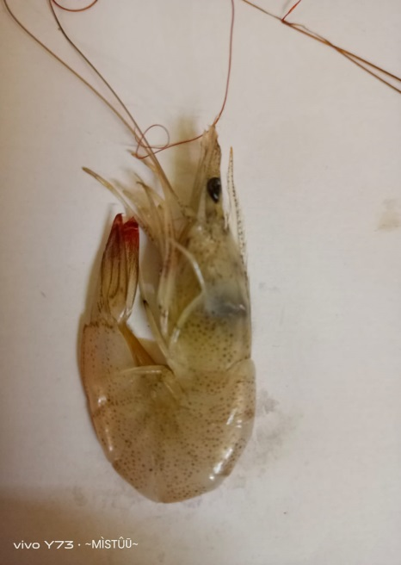 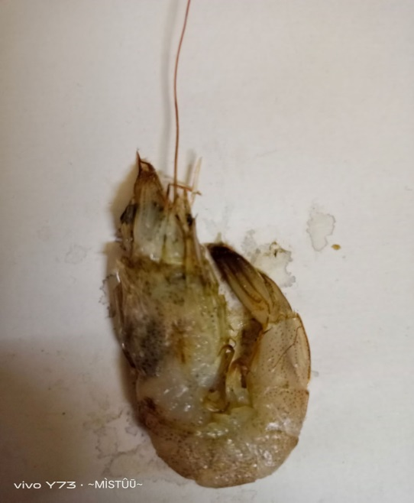

                   Fig. 1.3.1 Consumable (RGB) Fig. 1.3.2 Non-Consumable (RGB)

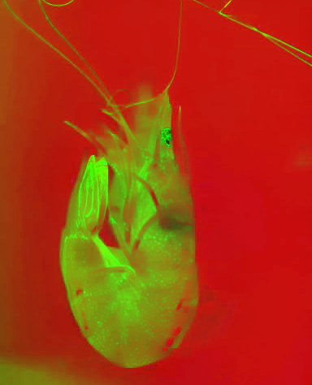 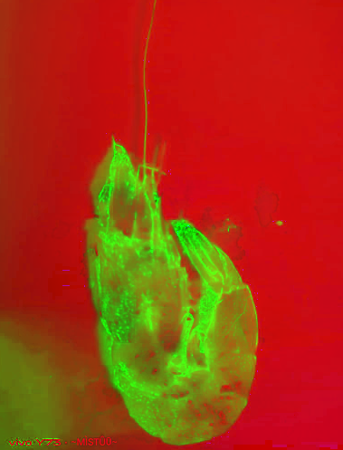

      Fig. 1.3.3 Consumable (HSV)     Fig. 1.3.4 Non-Consumable (HSV)

Methodology

1. Classification using Naive Bayes

Naive Bayes classifiers are a family of simple "probabilistic classifiers" based on applying Bayes' theorem with strong (naive) independence assumptions between the features (see Bayes classifier). They are among the simplest Bayesian network models, but coupled with kernel density estimation, they can achieve high accuracy levels.

**Bayes Theorem:**

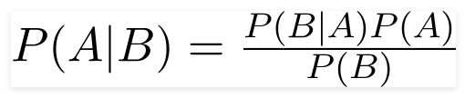

Fig. 2.1.0

Using Bayes theorem, we can find the probability of **A** happening, given that **B** has occurred (Refer Fig 2.1.0). Here, **B** is the evidence and **A** is the hypothesis. The assumption made here is that the predictors/features are independent. That is, the presence of one particular feature does not affect the other. Hence it is called naive.

The proposed system uses two color spaces (RGB and HSV) to train the model for each of the three dataset[5]. After training the system the model classified each of the dataset into two classifications: consumable and non-consumable. The result of the test dataset for each of the dataset is shown in the figures below as a confusion matrix (Refer Fig. 2.1.1 to 2.1.6).

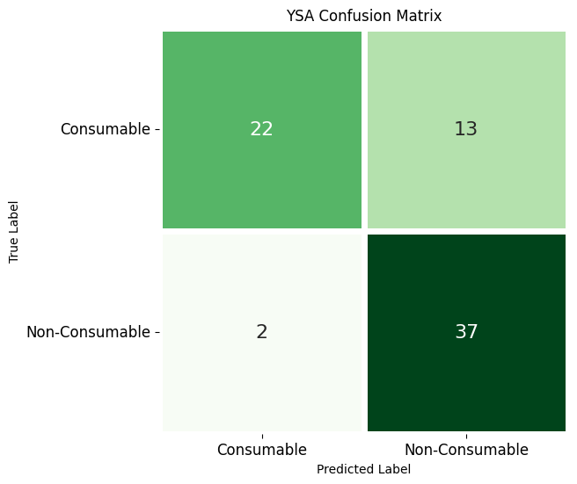 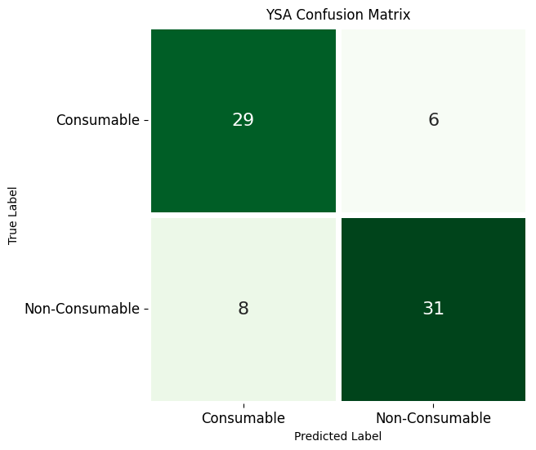

Fig. 2.1.1 Chicken Dataset (RGB)                  Fig. 2.1.2 Chicken Dataset (HSV)

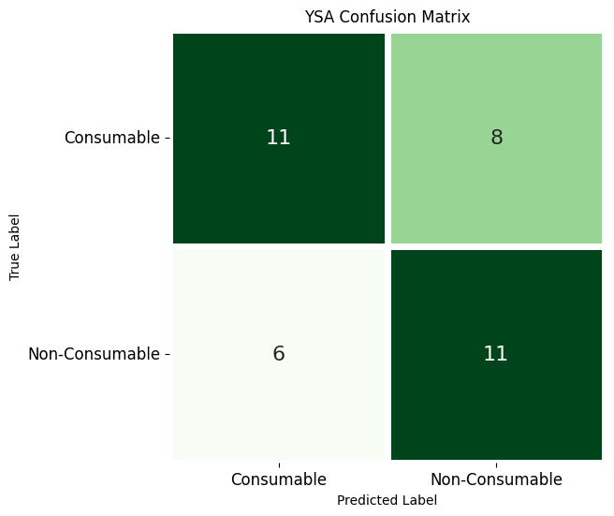 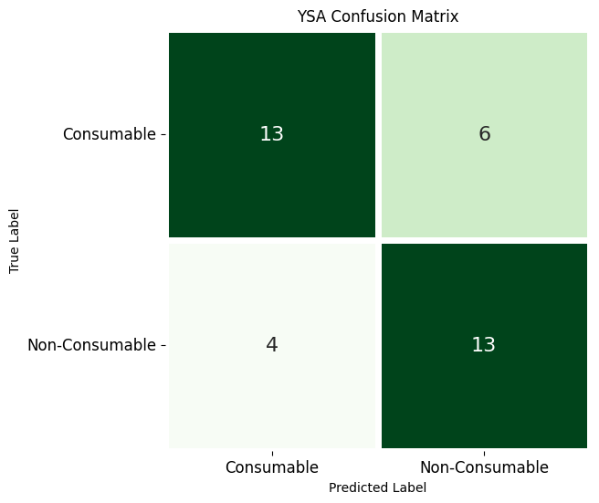

    Fig. 2.1.3 Fish Dataset (RGB)                    Fig. 2.1.4 Fish Dataset (HSV)

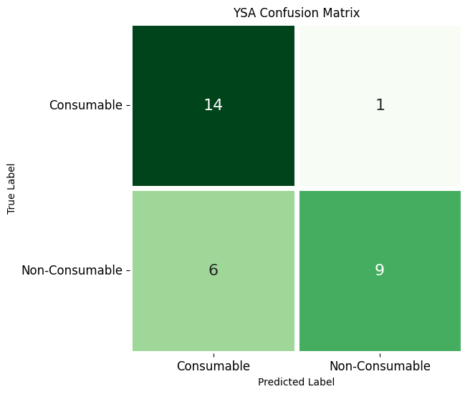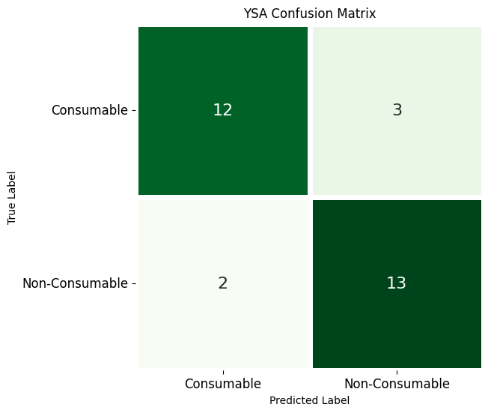

    Fig. 2.1.5 Prawn Dataset (RGB)                    Fig. 2.1.6 Prawn Dataset (HSV)

As we can see Chicken (Refer Fig. 2.1.1 and 2.1.2) and Prawn (Refer Fig. 2.1.5 and 2.1.6) provided a better accuracy than Fish (Refer Fig. 2.1.3 and 2.1.4) in this model. Chicken in HSV Color Space  (Refer Fig. 2.1.2) provided the best accuracy under this model.

2. Classification using KNN

In statistics, the ***k*-nearest neighbors algorithm** (***k*-NN**) is a non-parametric supervised learning method first developed by Evelyn Fix and Joseph Hodges in 1951, and later expanded by Thomas Cover. It is used for classification and regression. In both cases, the input consists of the *k* closest training examples in a data set[6]. The output depends on whether *k*-NN is used for classification or regression:

* In *k-NN classification*, the output is a class membership. An object is classified by a plurality vote of its neighbors, with the object being assigned to the class most common among its *k* nearest neighbors (*k* is a positive integer, typically small). If *k* = 1, then the object is simply assigned to the class of that single nearest neighbor.
* In *k-NN regression*, the output is the property value for the object. This value is the average of the values of *k* nearest neighbors.

*k*-NN is a type of classification where the function is only approximated locally and all computation is deferred until function evaluation. Since this algorithm relies on distance for classification, if the features represent different physical units or come in vastly different scales then normalizing the training data can improve its accuracy dramatically.

Both for classification and regression, a useful technique can be to assign weights to the contributions of the neighbors, so that the nearer neighbors contribute more to the average than the more distant ones. For example, a common weighting scheme consists in giving each neighbor a weight of 1/*d*, where *d* is the distance to the neighbor[6].

The proposed system uses two color spaces (RGB and HSV) to train the model for each of the three dataset. After training the system the model classified each of the dataset into two classifications: consumable and non-consumable. The result of the test dataset for each of the dataset is shown in the figures below as a confusion matrix (Refer Fig. 2.2.1 to 2.2.6).

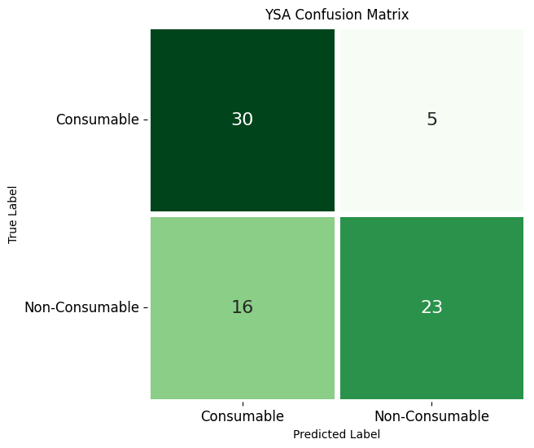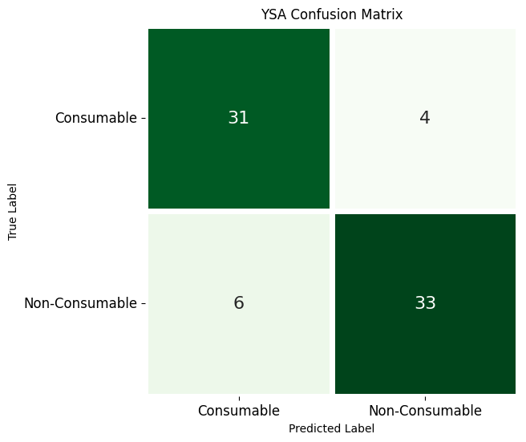

    Fig. 2.2.1 Chicken Dataset (RGB)                Fig. 2.2.2 Chicken Dataset (HSV)

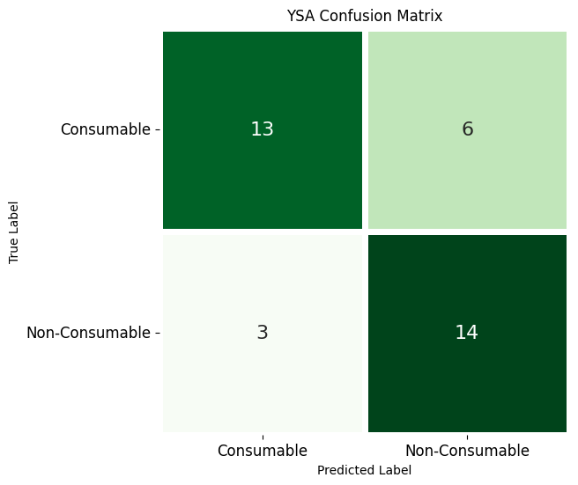 

    Fig. 2.2.3 Fish Dataset (RGB)                Fig. 2.2.4 Fish Dataset (HSV)

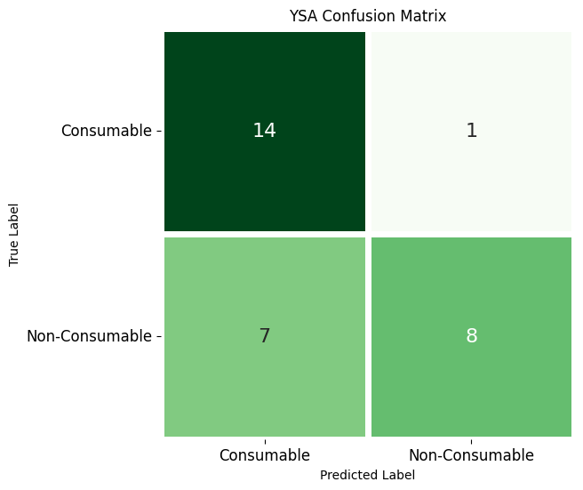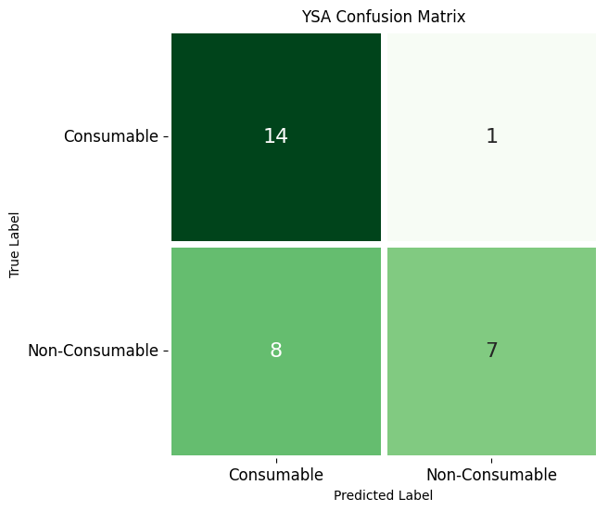

    Fig. 2.2.5 Prawn Dataset (RGB)                Fig. 2.2.6 Prawn Dataset (HSV)

As we can see all three datasets provide almost the same accuracy in RGB but in HSV color space Chicken (Refer Fig. 2.2.2) provides better results than the other two.

3. Classification using SVM

In machine learning, **support vector machines** (**SVMs**, also **support vector networks**) are supervised learning models with associated learning algorithms that analyze data for classification and regression analysis. Developed at AT&T Bell Laboratories by Vladimir Vapnik with colleagues (Boser et al., 1992, Guyon et al., 1993, Cortes and Vapnik, 1995, Vapnik et al., 1997) SVMs are one of the most robust prediction methods, being based on statistical learning frameworks or VC theory proposed by Vapnik (1982, 1995) and Chervonenkis (1974)[7]. Given a set of training examples, each marked as belonging to one of two categories, an SVM training algorithm builds a model that assigns new examples to one category or the other, making it a non-probabilistic binary linear classifier (although methods such as Platt scaling exist to use SVM in a probabilistic classification setting). SVM maps training examples to points in space so as to maximize the width of the gap between the two categories[7]. New examples are then mapped into that same space and predicted to belong to a category based on which side of the gap they fall. The proposed system uses two color spaces (RGB and HSV) to train the model for each of the three dataset. After training the system the model classified each of the dataset into two classifications  : consumable and non-consumable. The result of the test dataset for each of the dataset is shown in the figures below as a confusion matrix (Refer Fig. 2.3.1 to 2.3.6).

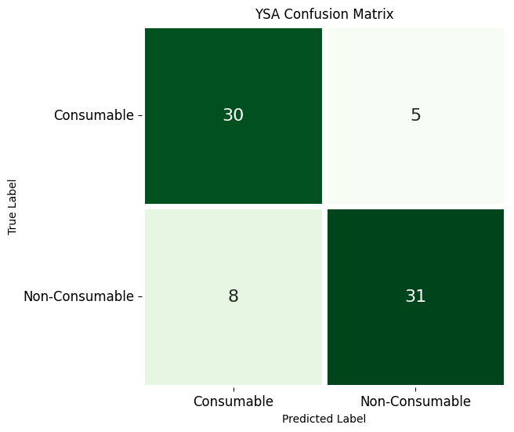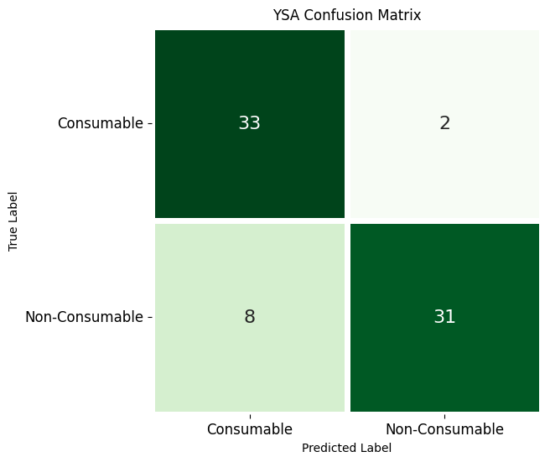

    Fig. 2.3.1 Chicken Dataset (RGB)                Fig. 2.3.2 Chicken Dataset (HSV)

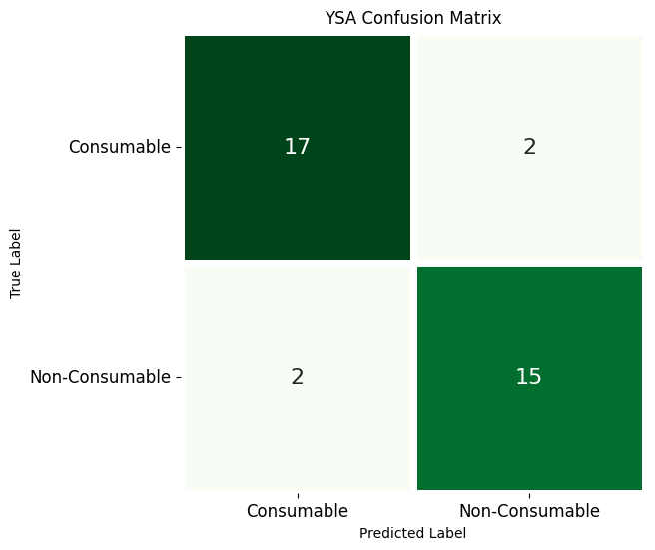   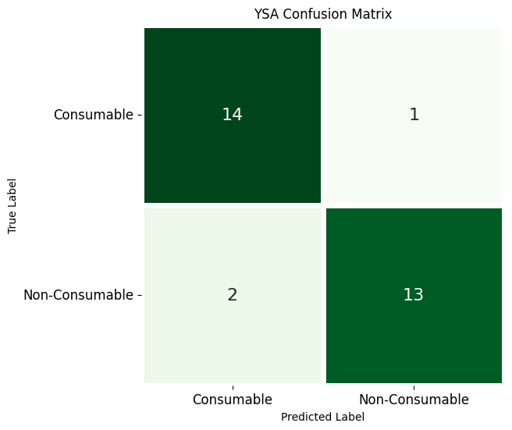

Fig. 2.3.3 Fish Dataset (RGB)                    Fig. 2.3.4 Fish Dataset (HSV)



    Fig. 2.3.5 Prawn Dataset (RGB)                Fig. 2.3.6 Prawn Dataset (HSV)

As we can see the datasets containing prawn provided excellent accuracy under this model in both color spaces (Refer Fig. 2.3.5 and 2.3.6). The other two datasets also provided good output in both color spaces.

4. Classification using Random Forest

Random forests or random decision forests is an ensemble learning method for classification, regression and other tasks that operates by constructing a multitude of decision trees at training time[8]. For classification tasks, the output of the random forest is the class selected by most trees. For regression tasks, the mean or average prediction of the individual trees is returned. Random decision forests correct for decision trees' habit of overfitting to their training set.  Random forests generally outperform decision trees, but their accuracy is lower than gradient boosted trees.[citation needed] However, data characteristics can affect their performance[8].

The proposed system uses two color spaces (RGB and HSV) to train the model for each of the three dataset. After training the system the model classified each of the dataset into two classifications  : consumable and non-consumable. The result of the test dataset for each of the dataset is shown in the figures below as a confusion matrix (Refer Fig. 2.4.1 to 2.4.6).

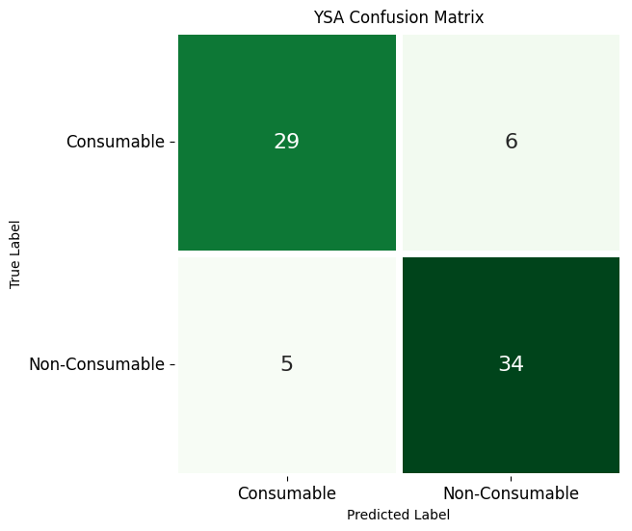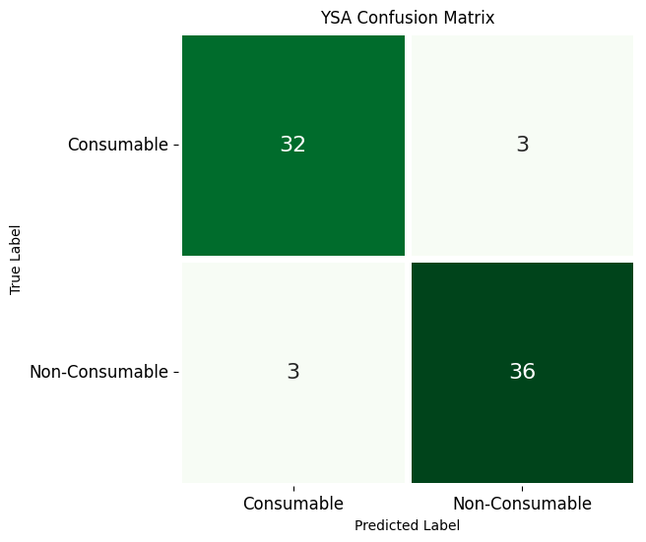

    Fig. 2.4.1 Chicken Dataset (RGB)                Fig. 2.4.2 Chicken Dataset (HSV)

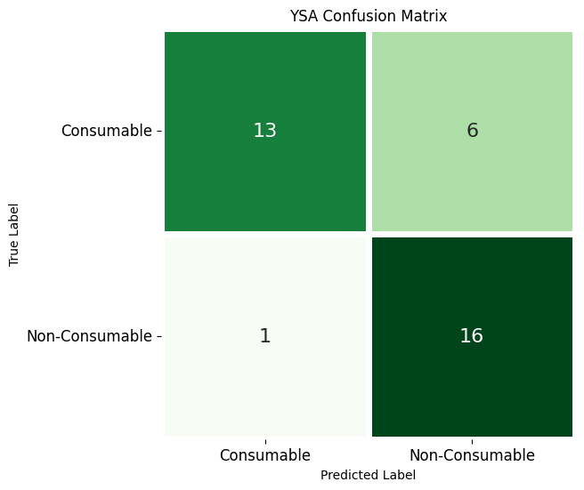 

    Fig. 2.4.3 Fish Dataset (RGB)            Fig. 2.4.4 Fish Dataset (HSV)

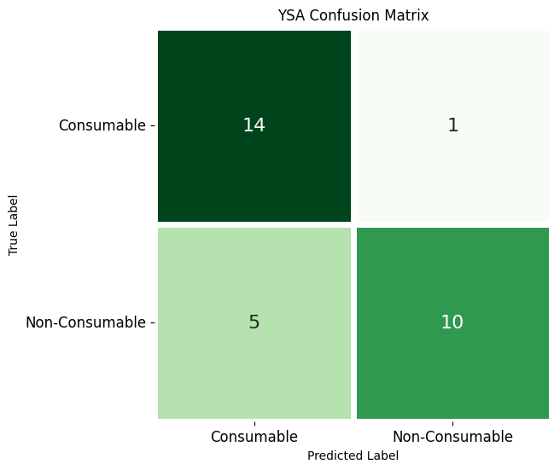 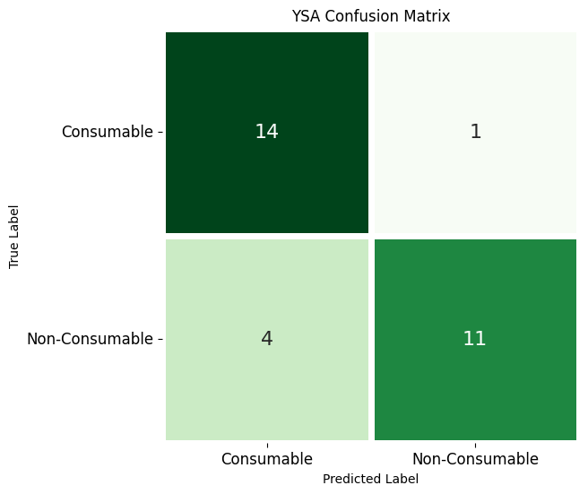

    Fig. 2.4.5 Prawn Dataset (RGB)              Fig. 2.4.6 Prawn Dataset (HSV)

As we can see Chicken and Fish equally provided good results under this method mainly in HSV color spaces (Refer Fig. 2.4.2 and 2.4.4). Prawn gave somewhat intermediate accuracy in HSV Color space (Refer Fig 2.4.6).

Results and Discussion

The experiment was to predict the freshness of meat on a given color space, and the results are the accuracies on the different dataset. The results show that image classification can be used to classify good (consumable) and bad (non-consumable) meat. One of the important results was quality of image and color space played a vital role in predicting the quality of meat. The results classified meat according to their freshness criteria. The biggest strength of the study was the model being simplistic, but limitations are less accurate compared to deep learning models, which are very complex. The variables were like, Random Forest being the best model for chicken classifier whereas for prawn the best was SVM.

The complete analysis is shown in table (Refer Table 1) below.

**Table 1: Accuracy observed for different models for different datasets under different color spaces.**

|  |  |  |  |  |
| --- | --- | --- | --- | --- |
| Classifier | Type of sample | Number of sample | Color space | Accuracy *  (%) |
| Naive Bayes | CHICKEN | 310 | RGB | 79.729 |
| HSV | 89.081 |
| FISH | 140 | RGB | 61.111 |
| HSV | 72.222 |
| PRAWN | 122 | RGB | 76.666 |
| HSV | 83.333 |
| KNN | CHICKEN | 310 | RGB | 71.621 |
| HSV | 86.486 |
| FISH | 140 | RGB | 72.012 |
| HSV | 75.023 |
| PRAWN | 122 | RGB | 73.333 |
| HSV | 70 |
| SVM | CHICKEN | 310 | RGB | 82.432 |
| HSV | 86.486 |
| FISH | 140 | RGB | 88.888 |
| HSV | 88.888 |
| PRAWN | 122 | RGB | 90 |
| HSV | 90 |
| Random Forest | CHICKEN | 310 | RGB | 85.135 |
| HSV | 91.891 |
| FISH | 140 | RGB | 80.555 |
| HSV | 88.888 |
| PRAWN | 122 | RGB | 80 |
| HSV | 83.333 |

* Taken by average from multiple results by randomizing the dataset.

When working with Chicken dataset in both the color spaces, we have observed that in all the algorithms HSV color space provided much better results than its RGB counterpart (Refer Fig 3.1). Out of all the algorithms Random Forest showed the best accuracy in both color spaces.

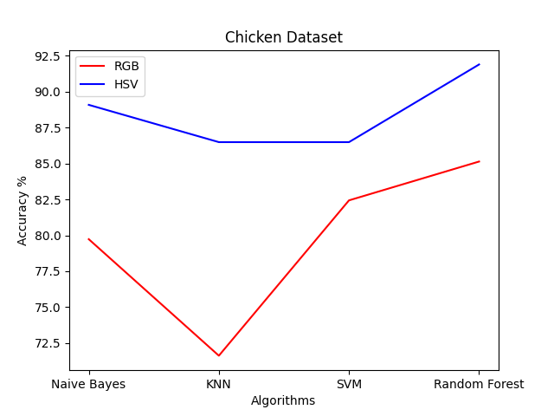

Fig. 3.1 Chicken dataset

When working with Fish dataset in both the color spaces, we have observed that in all the algorithms HSV color space provided slightly better results than its RGB counterpart (Refer Fig 3.1). Out of all the algorithms Random Forest and SVM showed the best accuracy in HSV color space.

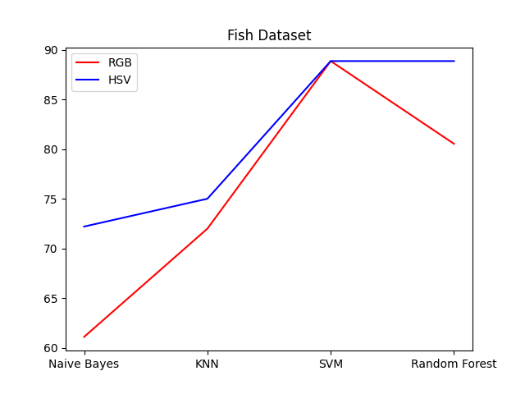

Fig. 3.2 Fish dataset

When working with Prawn dataset in both the color spaces, we have observed that in most of the algorithms in HSV and RGB color spaces provided almost the same accuracy (Refer Fig 3.1). Out of all the algorithms SVM showed the best accuracy in both color spaces.

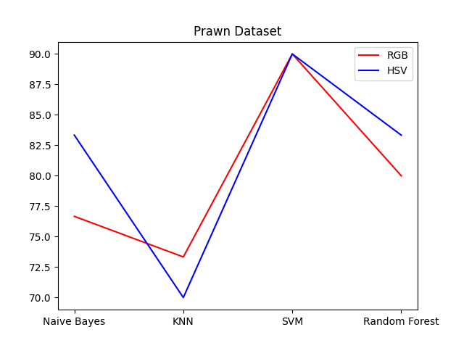

Fig 3.3 Prawn dataset

Conclusion

Machine learning models used for the above problem for each of the dataset some particular models provided better accuracy than the others. For example, Chicken dataset in HSV Color Space and in Random Forest model provided the maximum accuracy which is over 90% whereas Prawn and Fish in both RGB and HSV color space provided maximum accuracy of over 85% on SVM Model.

So, our aim will be to optimize these particular models for those datasets to provide better results for far more wide instances of those datasets.

Addition to that we will try more complex deep learning models like Convolutional Neural Network and compare the results with the above machine learning models and choose accordingly for further experimentation, keeping in mind of the computational complexity and the platform in which the project will going to be implemented.

Accurate meat freshness assessment is crucial for the problem of food quality. In general, meat freshness cannot be assessed accurately by any single conventional index because every index reflects only partial characteristics of a meat sample. To conclude, artificial vision and machine learning is a reliable technique, and it has shown its efficiency in many applications related to meat assessment.

References

[1] Chernov, Vladimir, Jarmo Alander, and Vladimir Bochko. "Integer-based accurate conversion between RGB and HSV color spaces." *Computers & Electrical Engineering* 46 (2015): 328-337.

[2] Kumar, Tarun, and Karun Verma. "A Theory Based on Conversion of RGB image to Gray image." *International Journal of Computer Applications* 7.2 (2010): 7-10.

[3] Kralik, Gordana, et al. "Quality of chicken meat." *Animal husbandry and nutrition* 63 (2018).

[4] Huss, Hans Henrik. *Fresh fish--quality and quality changes: a training manual prepared for the FAO/DANIDA Training Programme on Fish Technology and Quality Control*. No. 29. Food & Agriculture Org., 1988.

[5] Wijaya, Dedy Rahman, Riyanarto Sarno, and Aldhiaz Fathra Daiva. "Electronic nose for classifying beef and pork using Naïve Bayes." *2017 International Seminar on Sensors, Instrumentation, Measurement and Metrology (ISSIMM)*. IEEE, 2017.

[6] Adi, Kusworo, et al. "Beef quality identification using color analysis and k-nearest neighbor classification." *2015 4th International Conference on Instrumentation, Communications, Information Technology, and Biomedical Engineering (ICICI-BME)*. IEEE, 2015.

[7] Cortez, Paulo, et al. "Lamb meat quality assessment by support vector machines." *Neural Processing Letters* 24.1 (2006): 41-51.

[8] Astuti, Suryani Dyah, et al. "Gas sensor array to classify the chicken meat with E. coli contaminant by using random forest and support vector machine." *Biosensors and Bioelectronics: X* 9 (2021): 100083.